User Guide 40 Preparation of Practice Note 2
Purpose of this User Guide
The purpose of this User Guide is to assist Responsible Authority users about how to add the documentation and responses required for processing the Practice Note 2 within SPEAR.
Who should read this?
Primary audience: Responsible Authorities
For information: VCAT
Introduction
Under Practice Note Planning & Environment List (No. 2) – Responsible Authority information (as defined by VCAT), the Responsible Authority must give VCAT information about the application for review to understand the context of the application. This information can include copies of the permit application, relevant plans, details of the planning scheme requirements, the names and addresses of all objectors, details of referral authorities, and a copy of any officer’s report prepared for the application.
SPEAR provides functionality to Responsible Authorities to compile all PNPE2 documentation for VCAT where the application for review type is either s.77 (refusal), s.79 (failure), s.80 (conditions). The system will present the Responsible Authority user with the PNPE2 form (as defined by VCAT) and assist in answering questions by pre-populating the form with information held in the system.
40.1 How does a Responsible Authority prepare a PNPE2 response in SPEAR?
A Responsible Authority user can initiate the creation of a Practice Note 2 document in two ways:
- Via an optional action available any time after lodgment, or
- Via a mandatory action ‘Create PNPE2 - Information from Decision Makers’.

A mandatory action will appear if VCAT has entered the appeal details in to SPEAR. In this case, the mandatory action will be accessible on the VCAT tab rather than the Details tab.

The PNPE2 preparation screen will display answers to as many of the required questions as possible, leaving the user to check each piece of information, and provide information where it is not already held within the system.
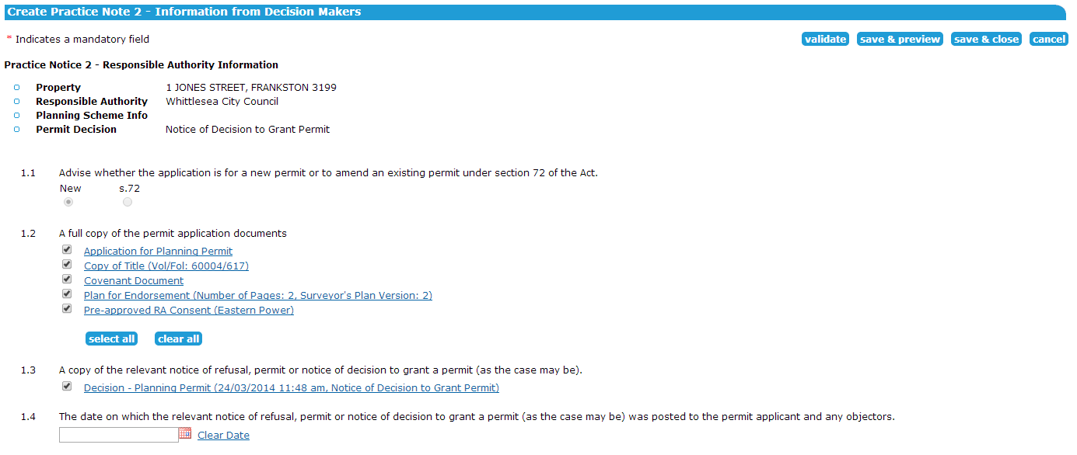
The first part of the PNPE2 preparation screen contains pre-populated information; use the date picker to insert the date of the notice.

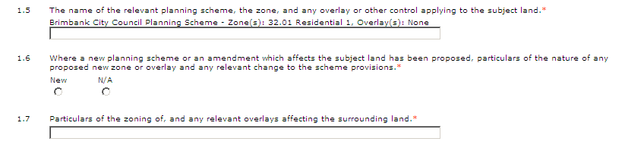
In the next section on this screen, the user will be required to add the planning scheme details.

The following section relates to advertising and notifications, and is pre-populated.

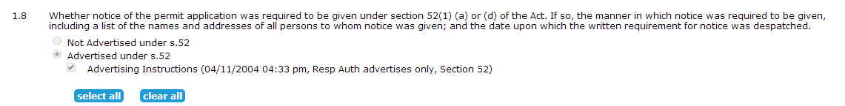
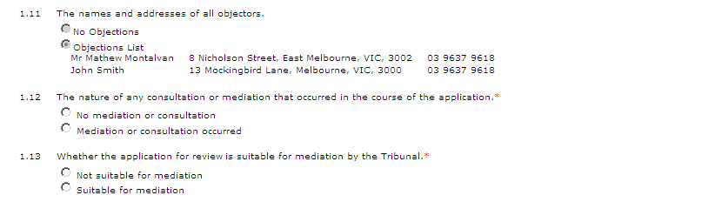
The next section provides information about objectors, regarding the nature of consultation and mediation.

Sections 1.14, 1.15 of the PNPE2 preparation screen are pre-populated with information about the referral authorities notified for this application and any requests for further information that the referral authorities may have made.
The next section requires the user to provide details about other government authorities that may be affected.
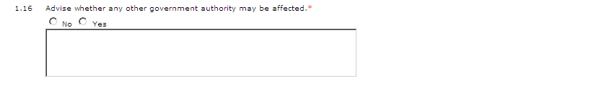
NOTE: This is a mandatory field and a ‘no’ response will still require a description in the text box.

The user will be required to add information about any covenants that may apply.
NOTE: This is a mandatory field and a ‘no’ response will still require a description in the text box.
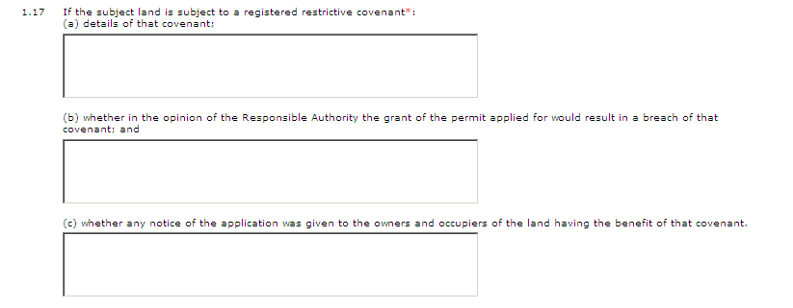
An estimate of the time required to present and hear the application is to be provided.

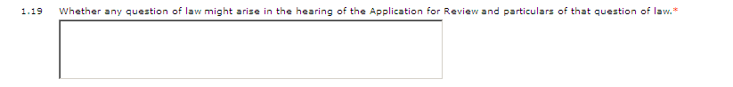
Provide details of any questions of law in the above field.

Attach any report prepared by the Responsible Authority for this application in the field below.

Sections 1.20 and 1.21 relate to the Responsible Authority providing additional documentation within the appropriate time.
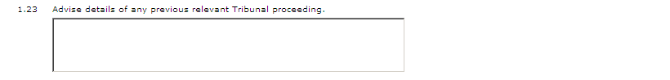
The user can provide details of any previous relevant Tribunal proceedings in this field.

Once the Responsible Authority user has supplied the required information, and checked the pre-populated details, click ‘save and close’.

The Responsible Authority user can also check that all the data entered is acceptable to the system by clicking the ‘validate’, preview the PNPE2 files by clicking ‘save & preview’ or cancel all changes made and return to the Details screen by clicking ‘cancel’. NOTE: ‘Save and close’ does not validate data.
Authenticating the document validates all the data entered in the wizard, and if any questions are either unanswered or have invalid data, the system will provide an inline error with a reference to each outstanding question. See 40.2 for details on how to ‘modify’ the document, to provide the relevant data.
40.2 Modifying or deleting the PNPE2
The Responsible Authority user can save the PNPE2 document at any time and return to the PNPE2 wizard by selecting the ‘modify’ action to the right of the document link in the Details tab. Similarly, the PNPE2 data can be deleted by selecting the ‘delete’ option (if it has not yet been authenticated). If you choose to delete the PNPE2 document, the mandatory action will be reinstated for the Responsible Authority to prepare the PNPE2.

40.3 What do I do now?
Once the PNPE2 document has been successfully authenticated, VCAT is notified, and the mandatory action is removed from the Responsible Authority. The Applicant Contact, relevant referral authorities, any guests associated with the application and VCAT can view the PNPE2 document.
VCAT requires the PNPE2 document to be printed by council and posted to VCAT for their review.
Need more information?
Further information on this topic can be found by:
- Visiting the SPEAR website www.spear.land.vic.gov.au/SPEAR
- Contacting the SPEAR Service Desk on 9194 0612 or email spear.info@delwp.vic.gov.au
- Selecting the Help link in the relevant area of the system.

